Dear please read the following details for the website / App development

Our business idea is to create a website and phone application that is an intermediate party between the customers and vendors. We are going to be an event planner website that will allow us to connect the customers such as individuals or companies who are looking to make an event and look for vendors that will supply them with that.

* The application I want to do will be in Arabic & English language. And maybe more languages in the future However, to keep the application able to be edited for having more languages for future development.
* I want to have access to the application using a control panel. The control panel should be in admin access which will be able to edit prices and add categories or products and track the orders.
* The control panel is to be using the website, not the application. The application will be Android & iOS. I want to have the application be used based on accounts either done by email verification or phone verification.
* The application should have the first page as a registration for user name and password either by email or phone as mentioned above.
* After that have the home page displaying the event that they could be doing such as a graduation party, wedding, engagement, or any other celebration
* There should be a search button in case they want to search for a certain product or service. I need to have the feature of the consumer's previous purchase so that he could re-order it again.
* The website should also have a feature where the customer can choose what they want and from the registered vendors, we can suggest the cheapest and best option for the customer.
* We need to have different payment methods such as PayPal, credit card and pay by cash on delivery.
* I want to have an account info and setting tab which will include such information about the country, location, age, gender and etc.
* I want to have a tab for the inquiries, FAQs, company mission statement and vision and have a report/complaint for the consumers.
* To also have a blockage feature for certain users.
* I want to have a calculator of the orders per day, the categories most visited and the locations with the most traffic in general based on a daily, weekly, monthly and yearly basis.
* I want to also to have the full sources of the application so that I have the full rights that in the future any developer could be able to develop or access the app and website.
* I want to have a personal inquiry button where people could send the management a message regarding anything.

Finally, I will want to have proposals for the prices to be done and the duration for developing the app. The developer will be also responsible for having the application to be submitted on the google play and apple store. I will be providing the logo and branding and the domain for the developer.

Thanks

Best regards

Below is a sample website

Page 1 – Landing Page

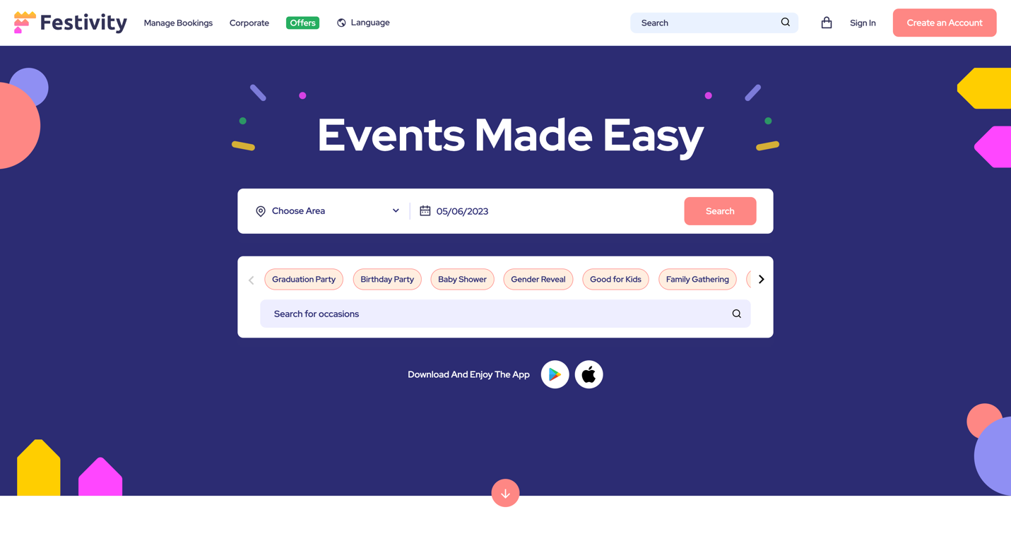 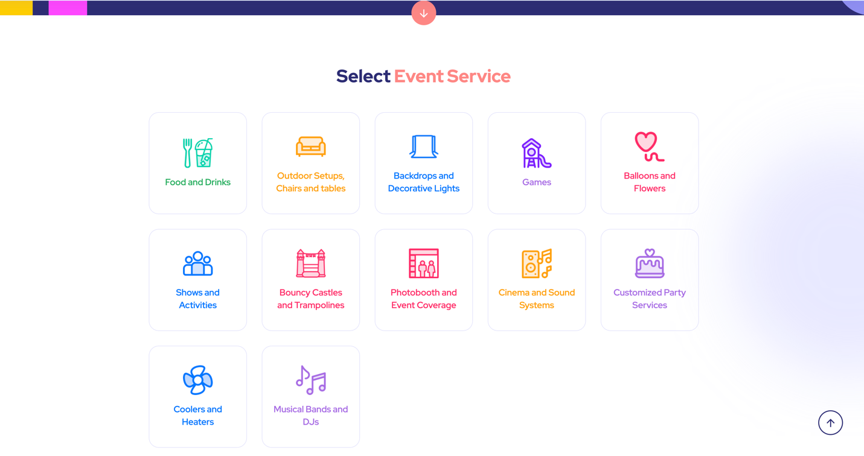

Page 2 – if you choose an occasion – Related products and services show



Page 3 – if you choose a category, vendors will show



Page 4 – after choosing a product

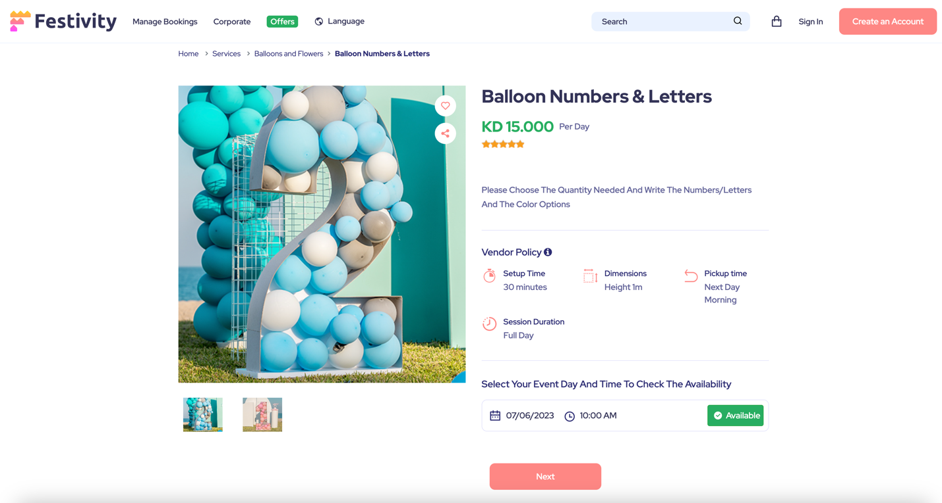

Page 5 – ordering the product

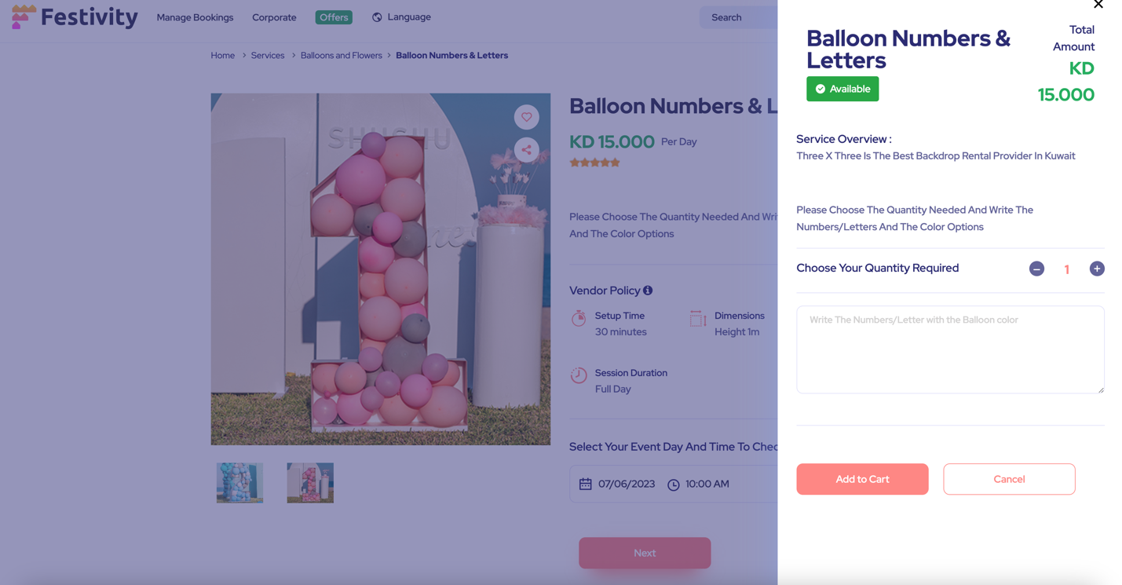

Page 6 – paying for product and selecting the time

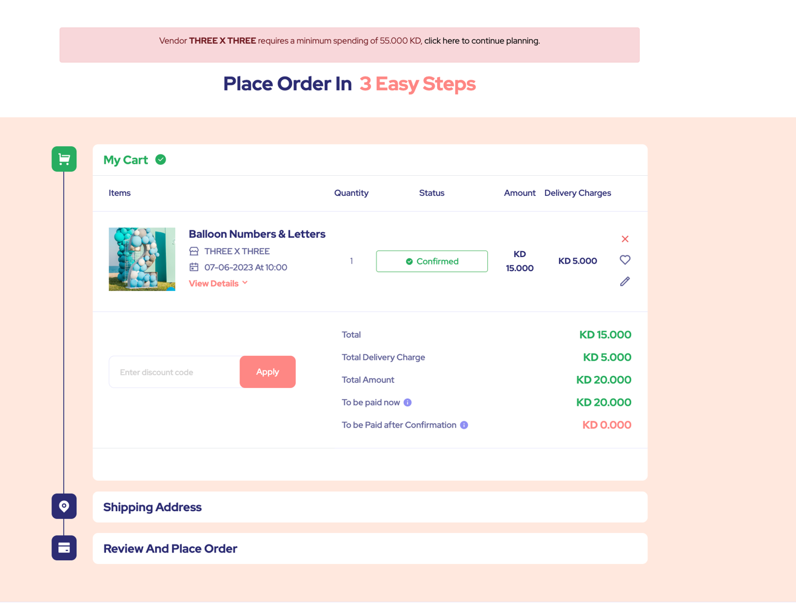

Page 8 - Offers Tab on Home page

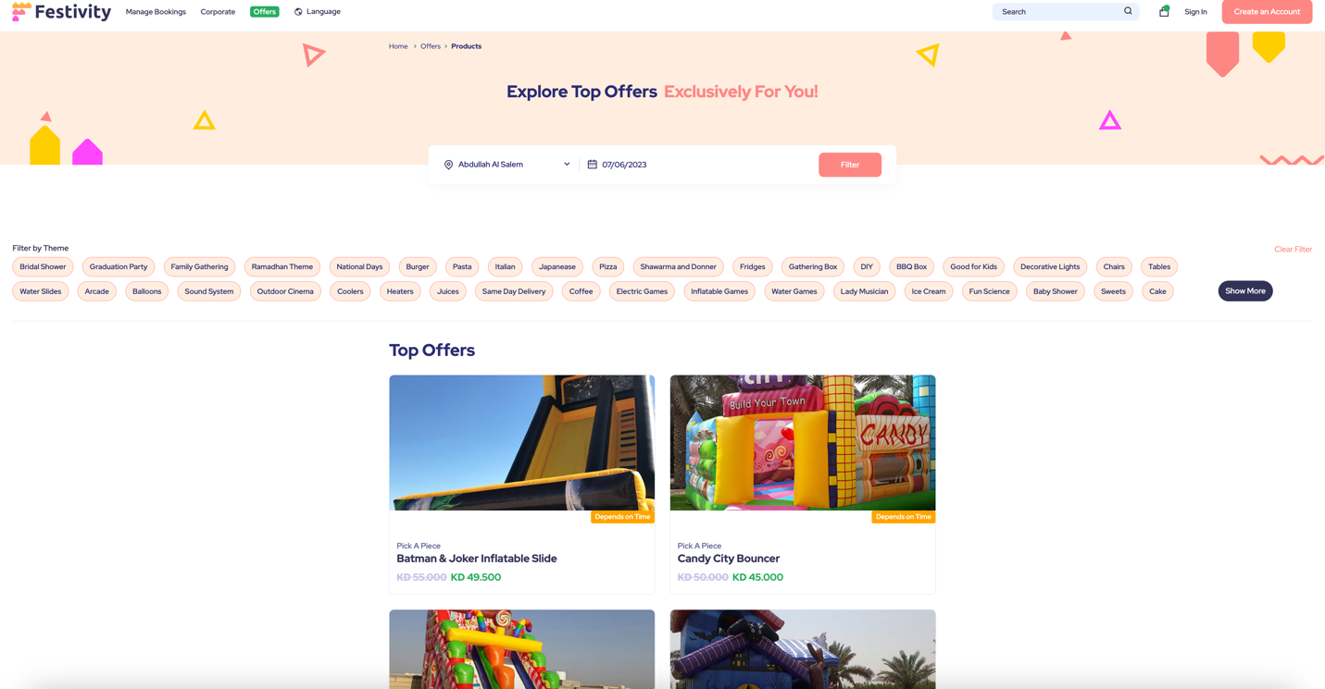

Page 9 – Corporate Tab

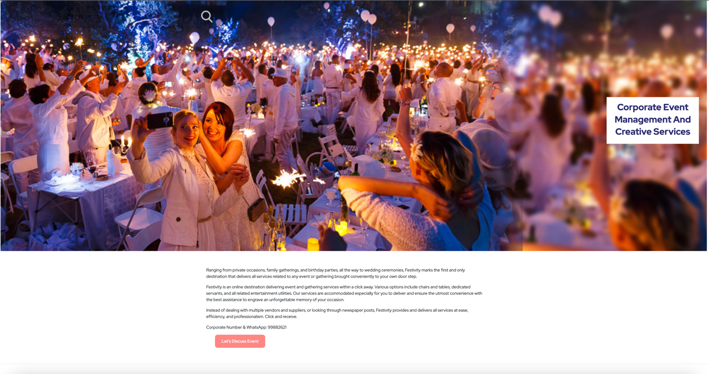

Registration Page

